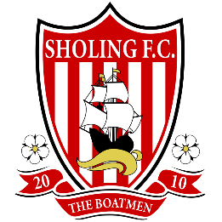
SHOLING FC
2015/16 Season Ticket Application

Name:
Address:

Post Code:
Telephone:

Email:
Season Ticket Type (Please put Quantity in the appropriate place):

Adult : ......... Concession : ....... U16 : .......

Childs Name: ____________________________________________
(Please complete if for a U16 Season ticket)  Ticket Type | Early Bird Price | Standard
Adult | £70 | £80
Concession (Students, Disabled & Over 65’s) | £35 | £40
Under 16’s | £21 | £25
Signed:

Date:

Cheques to be made payable to SHOLING FC

Season Tickets will be valid for all Sydenhams Wessex League matches, but concession prices will be available for all Cup matches

**** Early bird prices finish 31st July 2015 ****

Proof of age may be required from those who are close to the age brackets.

Student Union Cards may be requested from University aged students.

Please tick this box if you would not like to receive further communication from SHOLING FC. (Your details will not be passed on to any third parties and you will only be contacted with news, offers and information by SHOLING FC)

Forms to be returned via email to: secretary.sholingfc@gmail.com

Or post with payment to : Sholing FC, 43 Kingsclere Avenue, Southampton SO19 9LB

